**CMPE281_TEAM2_FINAL_REPORT**

**1. Team 2**

|  |  |
| --- | --- |
| NAME | L3SID |
| Bing Shi | 039 |
| Sterling Tarng | 221 |
| Tingting Wang | 884 |
| Zhenyu Zhong | 513 |
| Xiaoyu Zhou | 038 |

**2. The project topic and proposal**

**Topic**: SmartCalendar

**Proposal**: SmartCalendar is more than a regular calendar. It could also alerts the users on how to enhance their lifestyle based on their calendar and relevant data. It will utilize cloud concepts such as scalability and elasticity to give user maximize using experience and save cost for developers. SmartCalendar’s “smartness” is not only represented by its on-demand provisioning but also by its ability to aggregate and parse data from various sources and utilize the data in a way beneficial for the user. For example, it will alert the user to carry an umbrella when there is a forecast of rain; it will update a user’s calendar based on current traffic. Additionally, it will give the user health tips such as when to eat, when to workout, and when to sleep, etc. The primary goal of this application is to aid our users in their time management in order to live a more efficient life.

**3. If applicable, briefly survey previous works if any (include references)**

There are some similar works before, such as an alarm built based on train schedule, a notification system constructed based on weather condition, a health alert enabled on some wearable devices when a user needs to take a time to walk, etc. However, none of them were inclusive enough to incorporate all the functions mentioned above and most of them were not using cloud technologies.

**4. Describe the intended users or service consumers**

Users who need to manage their schedules based on their own input and the online resources, e.g., weather information, public transportation schedule. Additionally, this cloud application will aid users who would like to live a healthier end efficient life.

**5. Specify final list of functionalities/operations (and, if different from the midterm report, status of each planned one)**

Android Client:

* ● Input calendar event with event name, start time, end time, whether it is all day event,
* whether it is going to repeat, when will repeat end if repeats, event location,
* receive alert or not, and description of the event
* ● Browse future calendar events
* ● Receive notifications of event alert, including weather, temperature, travel time with live traffic condition, distance between original location and destination
* ● User settings: whether to receive alert, whether to receive traffic alert.

Web Application Service

* Insert and select calendar events from AWS RDS mySQL
* Integrate weather forecast, traffic condition, and calendar events to alert users with upcoming events
* Customize alert with user’s setting
* Response client’s get request with all future events

**6. Final design of the project**

**6.1 Architecture**

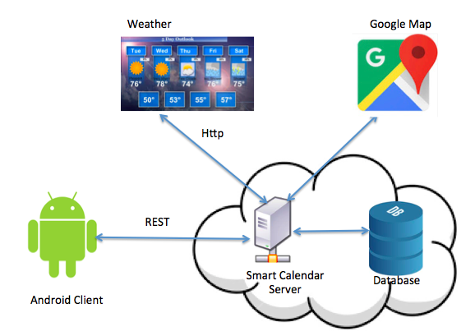

**6.2 Components:**

**6.2.1 Android Client**

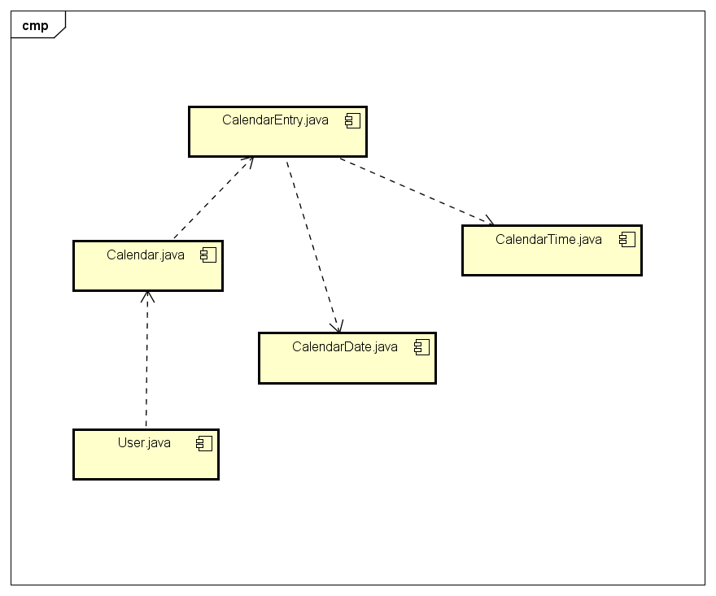

**6.2.2 Smart Calendar Server**

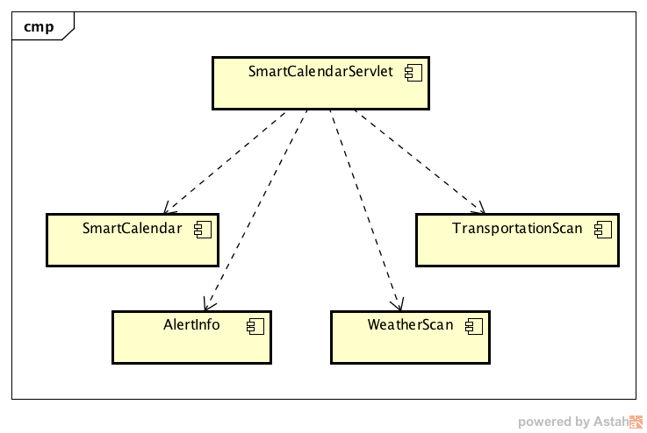

**6.3 Sequence diagram:**

6.3.1 Android

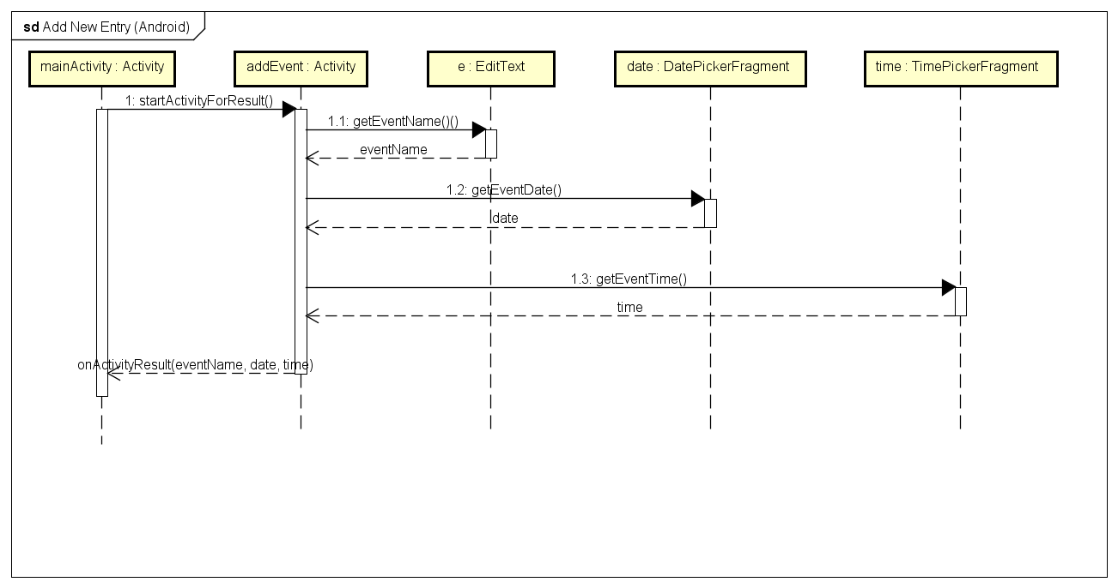

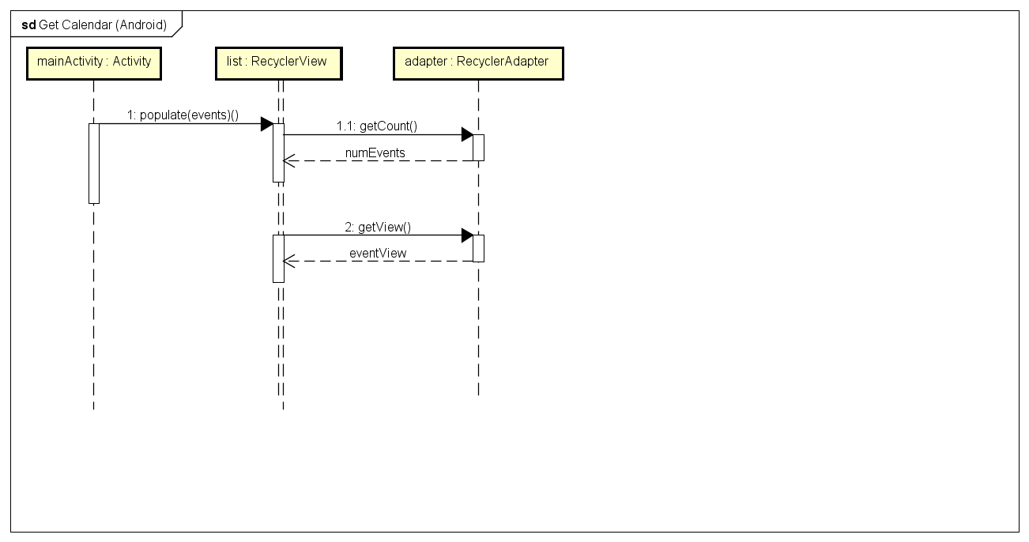

6.3.2 Server

6.3.2.1 Post Request Sequence Diagram

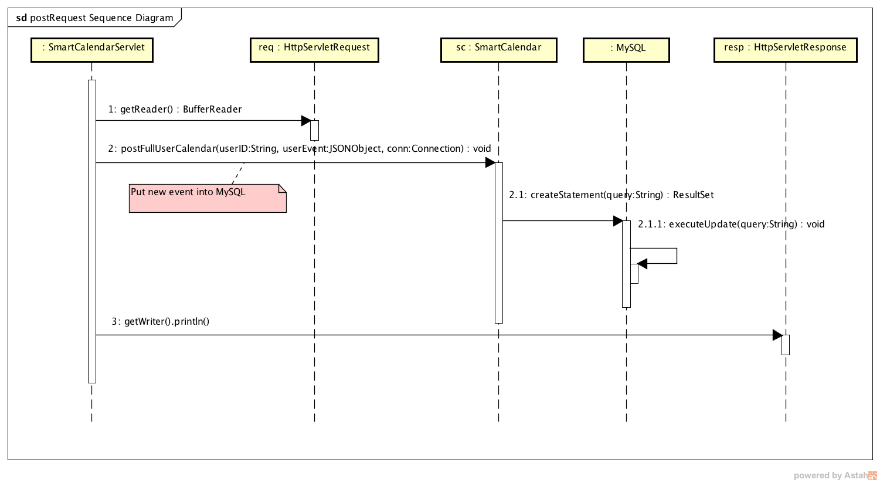

This diagram illustrates the process when the client sends a new event to the SmartCalendar server(SmartCalendarServlet). The server records the new event into the database.

6.3.2.2 Get Request Sequence Diagram

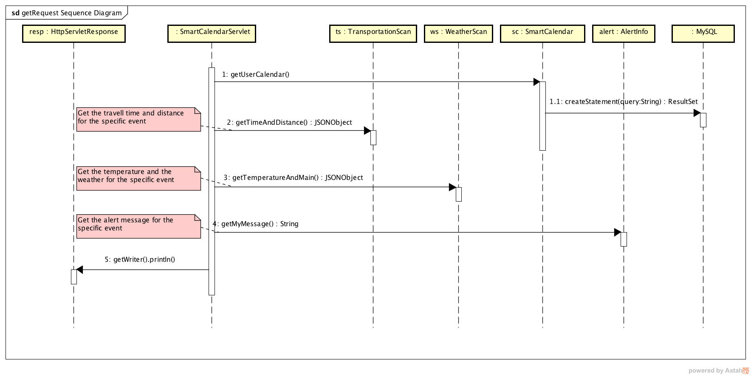

This diagram illustrates the process the android client send the get request to server. The server get the information from database, and get the weather and transportation information. By merging the weather and transportation information and the events, the server sends back the message to the client combined with the alert.

**6.4 Flow of data**

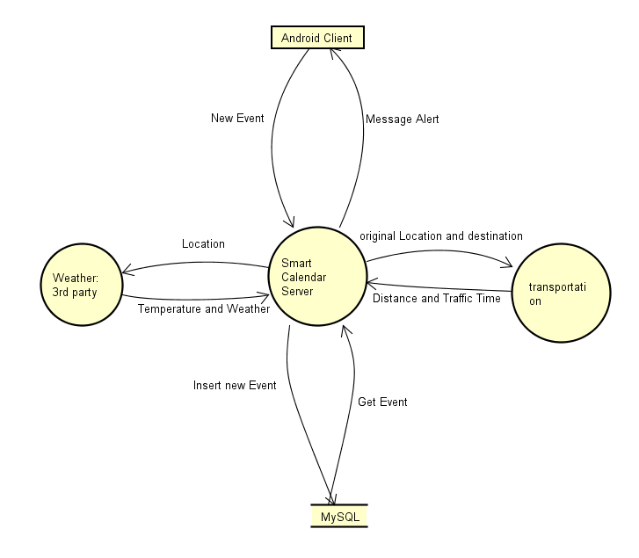

**6.5 Tradeoffs**

In our project, we use MySQL instead of NoSQL, this has pros and cons:

**Pros:** easy to query the data using different types of properties (indexes on columns) instead of needing to build custom search structures for every type of search.

**Cons:**  during implementation, when we need to update our database to have more attributes, the communication to the database part of the source code needs to be carefully updated.

**6.6. Any major design decisions (and why)**

AWS: AWS has been the leader of infrastructure as a service in six consecutive years according to Gartner 2016. It has more capabilities, for example, auto-scaling, elastic load balancing, snapshot, etc. What’s more, we would like to experience more cloud infrastructure since we have deployed rest server on Google App Engine in our previous homework.

Android: Android has the biggest market share among all mobile development system. It is also developer friendly, easy to setup environment in different operating systems, cheaper and easier to publish on Google Play.

AWS RDS: similar reason as previous Tradeoff section, we decided to use relational database to execute query more efficiently.

**7. Final implementation of the project, including (but not limited to) OS, languages, platform, technologies, and frameworks or any cloud mechanisms and/or architectures you have leveraged**

**7.1 OS, languages, platform, technologies, and frameworks**

OS: Linux, Android

Languages: Java, Android Java, XML

Platform: AWS

Technologies: AWS EC2, AWS RDS, Elastic BeanStalk, Restful-based-service

Cloud mechanisms: High Availabilities, Scalability, Elasticity, Load Balancing

(Multi-Availability Zone, Encryption is available in pay-tier)

7.2 **any cloud mechanisms and/or architectures you have leveraged**

High Availabilities, Scalability, Elasticity, Load Balancing

(Multi-Availability Zone, Encryption is available in pay-tier)

7.3 **Sample execution (screen shots, etc.) for important functionalities / operations**

**7.3.1 Display all future events upon start of the application**

**Andriod:**

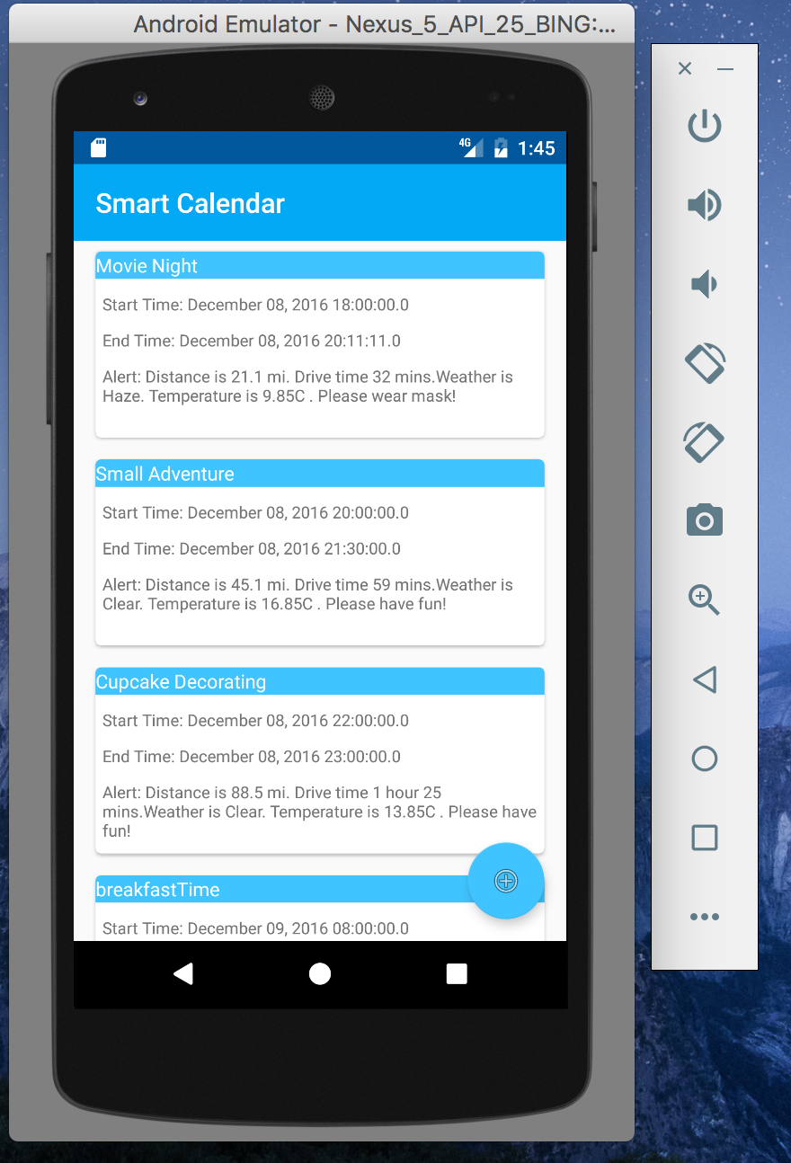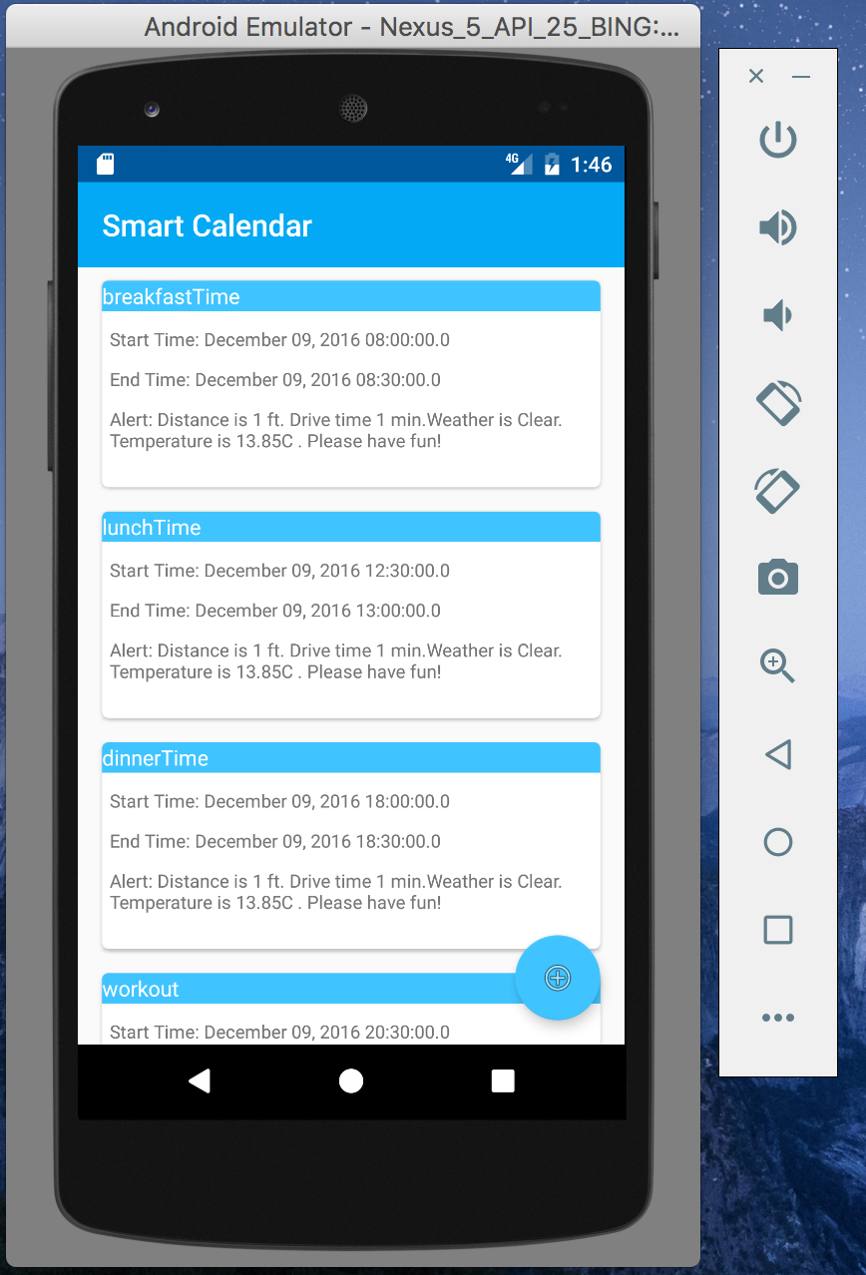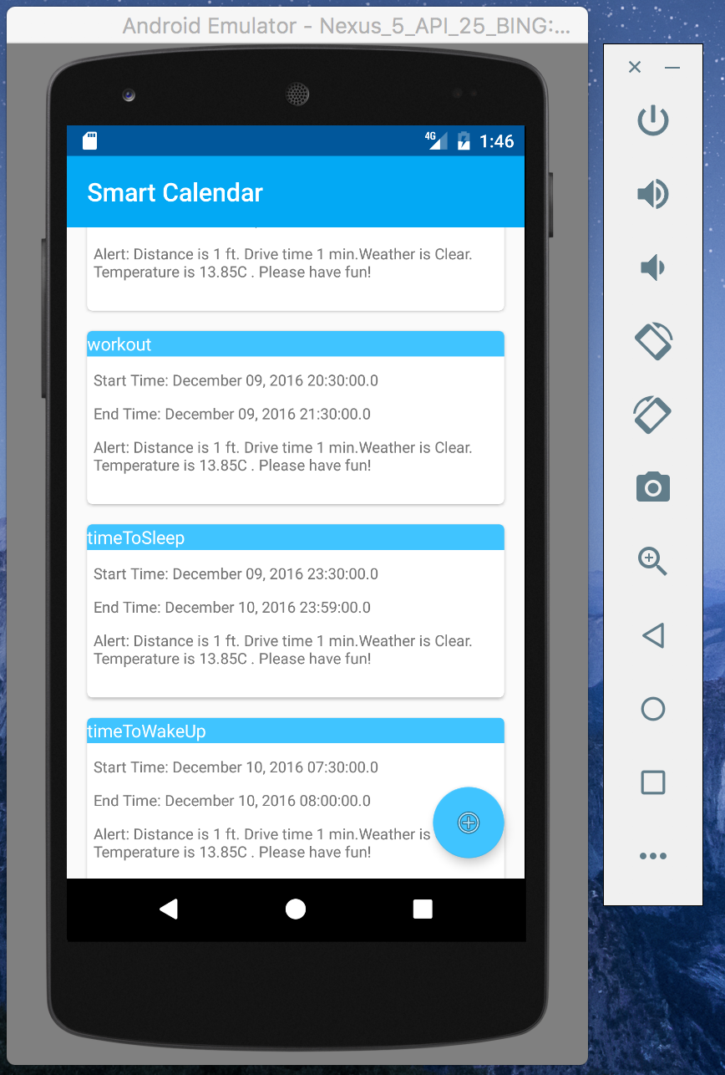

**Database:**

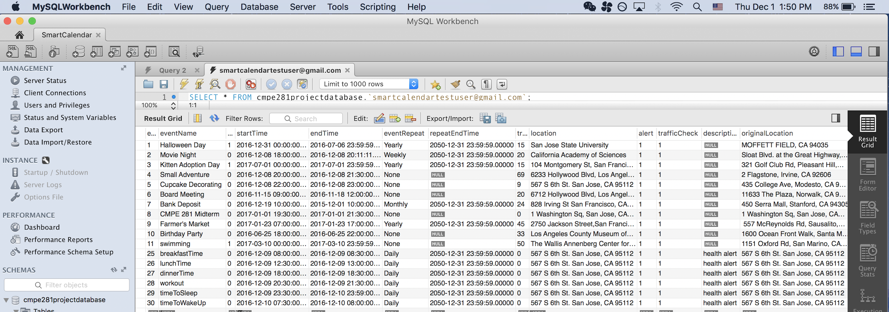

**7.3.2 update event lists hourly(for test purpose, we set it to update every minute)**

**Operation: Android can INSTANTLY reflect the changes from database.**

**Flow: change from database → instantly reflection in Android**

**Database change event “Movie Night” startTime to “18:11:11”, endTime to 22:22:22**



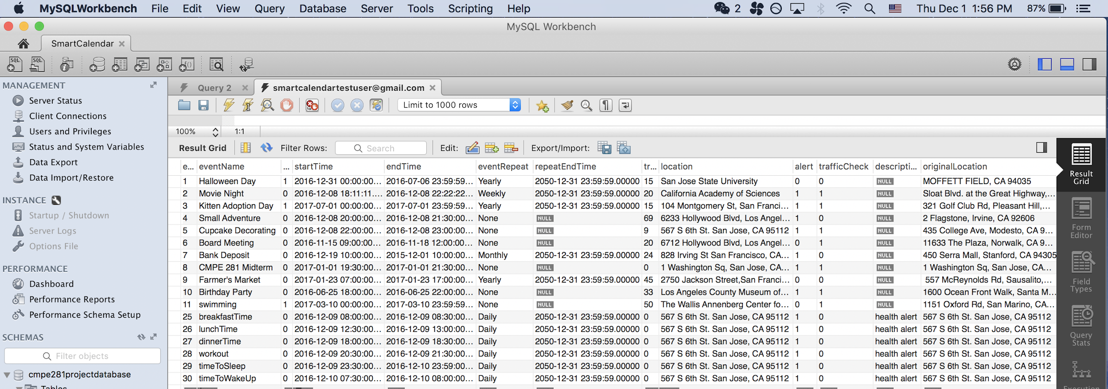

**Android:**

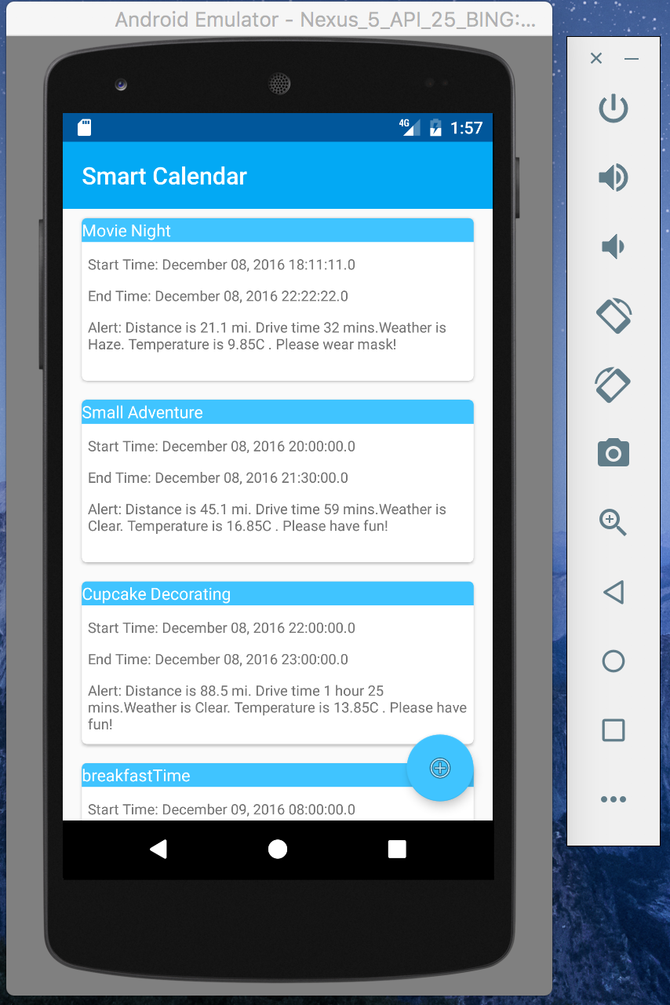

**7.3.3 Add new event**

**Operation: insert event information into database from Android**

**Data flow: Android App → Server (post) → Database Update**

**Android: add event and list after adding**

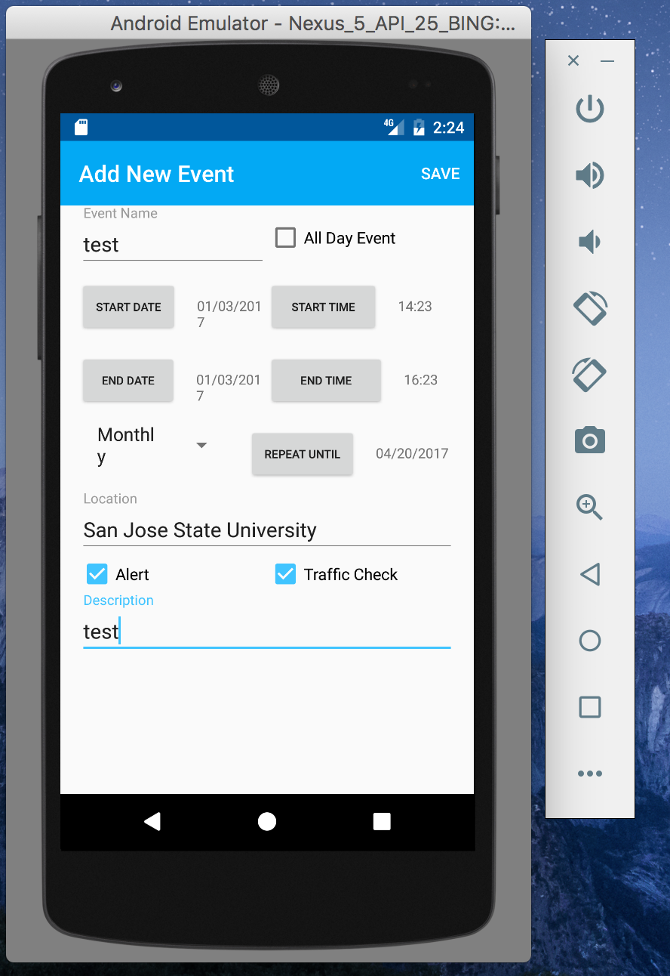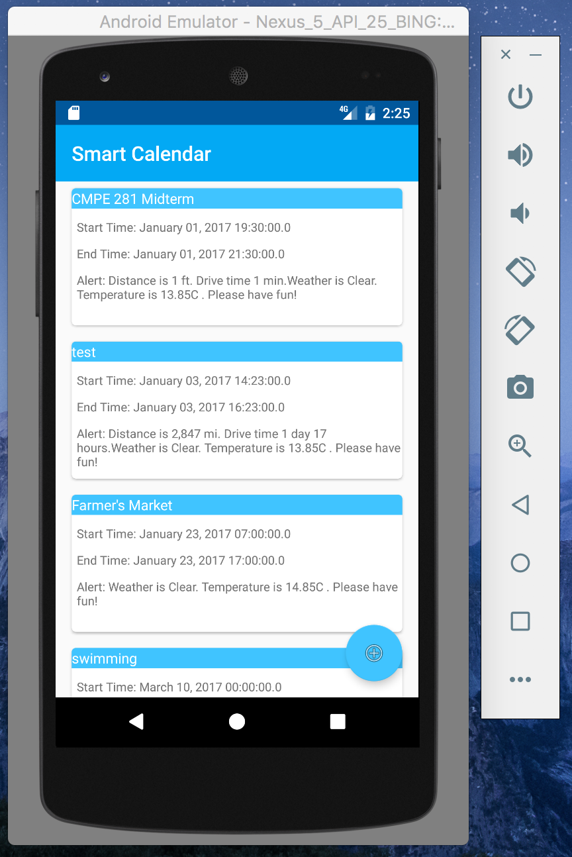

**Database:**

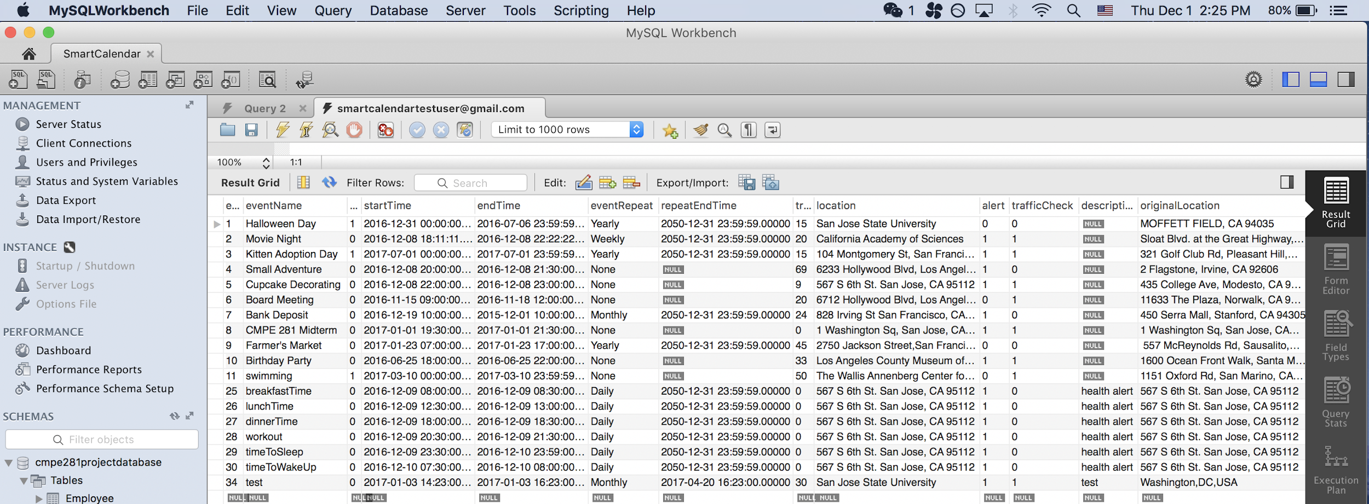

**7.4. Third Party API**

**(1)The transportation time and distance**

The date is from “Google App API”:

https://developers.google.com/maps/documentation/distance-matrix/

**(2)The weather and temperature**

The date is from “OpenWeatherMap”: <http://api.openweathermap.org>

**8. Any major modifications from the midterm report / proposal and why**

Firebase Cloud Messaging: We run into difficulties to implement this function, due to time constraints, we replace this function with get rest alert.

Userlogin: Due to time constraints, we didn’t have time to add more UI and java functions to implement this function.

Google calendar: We were able to import google calendar events to database. More functions like sync with google calendar and login/signup with Google account is still in progress.

**9. Any uniqueness (design, implementation, etc) that you are proud of (more to be added)**

Design: Ability to integrate cloud information (weather information, transportation information) with user input to provide a “smart” calendar.

Implementation: Ability to interact with relational database (MySQL) with key-value pair.

Android UI: The UI is customer friendly.

**10. Milestones Final major areas/components/ task splits for each member**

|  |  |  |  |
| --- | --- | --- | --- |
| **FINISH DATE** | **TASK** | **TASK PERFORMER** | **DETAILS** |
| OCT 20, 2016 | Project Proposal | ALL TEAM MEMBERS | Group meetings scheduled to gather information and draft the proposal |
| OCT 24, 2016 | Environment Setup | ALL TEAM MEMBERS | Group meeting scheduled to set up environment on each group member’s laptop, including bitbucket, github, AWS RDS, AWS EC2, MySQL workbench, etc. |
| OCT 31, 2016 | Task Divide & “API” definition | ALL TEAM MEMBERS | Group meeting scheduled to split workload and discuss about “API” for each part(how different part communicate with each other) |
| NOV 18, 2016 | Implementation | Sterling Tarng | Developed Android client UI  Enabled Device Alerts on client |
| NOV 19, 2016 | Implementation | Xiaoyu Zhou | Basic java program to connect to AWS RDS and populate into/massage it (basic string-type communication). |
| NOV 21, 2016 | Implementation | Tingting Wang | Integrated weather information and traffic information with calendar event. |
| NOV 22, 2016 | Codes coordination | Tingting Wang  Xiaoyu Zhou | Testing of code coordination. E.g., integration of weather information with database information |
| NOV 23, 2016 | Implementation | Bing Shi | Integrated events with Google Calendar.  Use FCM to push notification into Android. |
| NOV 23，2016 | Implementation | Zhenyu Zhong | Write server end Restful services,  Use FCM to push notification into Android. |
| NOV 26, 2016 | Implementation | Xiaoyu Zhou | Based on other code parts, enrich the communication with database, changed from String-type communication to JSON-type communication. |
| NOV 26, 2016 | Implementation | Bing Shi  Sterling Tarng | Main function, e.g., for a certain time, the Android |
| NOV 28, 2016 | Code Merge and Testing | ALL TEAM MEMBERS | Group meetings scheduled to merge/test our codes together and make different part to coordinate with each other. |
| NOV 29, 2016 | Final Report | Zhenyu Zhong | Draft final report. |
| NOV 29, 2016 | Presentation Slides | Bing Shi  Tingting Wang | Draft presentation report. |
| NOV 30, 2016 | Sample Execution, Finalize Report & Slides | ALL TEAM MEMBERS | Group meeting scheduled to do sample execution, finalize the final report & presentation slides. |

**11. Test plan execution**

**same with sample test mentioned above(section 7.3).**

**12. Project postmortem and potential improvements (such as issues uncovered, how to improve XYZ, etc.)**

FCM implementation: “Smartness” currently is for Android app (client-end) automatically doGet from server for every certain time. It can be improved by letting the **server-end** to automatically push notification to the Android-end by using FCM.

Google Calendar implementation: User is able to login with their google account, and all google calendar events can sync with SmartCalendar events.

Login/signup function: Allow users to signup/login with their account, and encrypt their login information.

Delete and edit event function: Allow users to delete and edit events.